Northern Slopes Initiative
AUGUST 2021
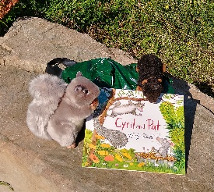
Story trail

Come and enjoy a story trail all about two squirrels. Cyril and Pat are best friends and remain so despite challenges from many directions. And there are some activities provided by the author Emil Gravett, https://www.emilygravett.com/activities
The trail will follow the path from Wedmore Vale to Cavan Walk and will be available from the 14th August.

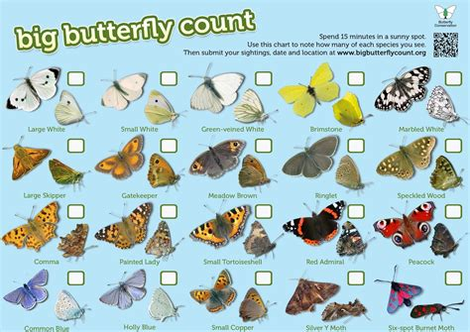
Big Butterfly Count

The Slopes are a great place to see butterflies and if you want to have fun spotting butterflies and add to understanding of how butterflies are doing why not take part in the Big Butterfly Count. Just find a comfy place to sit for 15 minutes and log what you see on the website or app. The Big Butterfly Count goes on till the 8th August
https://bigbutterflycount.butterfly-conservation.org/

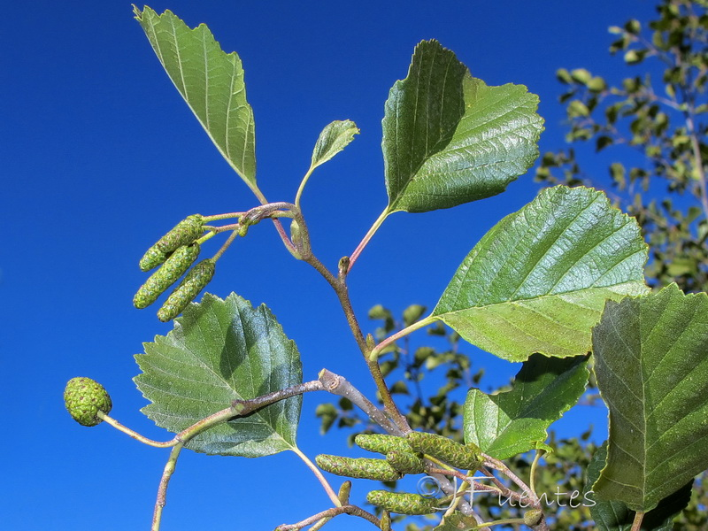
Trees

Two Alder trees (Alnus glutinosa) can be found on the Slopes. Although not a Conifer, it bears small cones, which contain the seeds. The wood burns with a fierce heat, making the best charcoal and was used to manufacture gunpowder. Conversely it was also boiled and used to heal burns. The wood is soft and when cut is white but soon turns red.
Jim Smith Filwood Tree Champion

Street party for Knowle West

An antidote to a year+ of lockdown restrictions and absence of live entertainment SMOOSH! invites residents and visitors out onto their doorsteps to dance and sing along in magnificent, cacophonous, communal karaoke – a ‘masseoke’! SMOOSH! brings a 70-piece wind and brass band and a troop of dancers performing rip-roaring pop karaoke tunes on the move to the streets of Knowle West, Bristol this September for a safe, inclusive, and celebratory mobile street party. Friday 17 September 2021, 4pm & 6.30pm
https://paraorchestra.com/our-projects/smoosh/

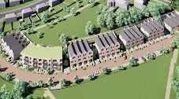
Kingswear update
A decision on the Kingswear Road planning application is yet to be made. A number of objections to the development were submitted and comments from organisations from formal consultees.

Motorbikes

Many people have noticed that motorbikes are being ridden on the Slopes. NSI has been advised to encourage residents to log motorbike use by ringing 101 or Crimestoppers 0800 555 111.

Joining the NSI

The Northern Slopes Initiative (NSI) is a group of volunteers seeking to maintain, conserve and enhance the Slopes. If you would like to be more involved in caring for the Slopes or have ideas about the Slopes you’d like to share, get in touch by:

Email: enquiries@northern-slopes-initiative.co.uk
Website: www.northern-slopes-initiative.co.uk
Facebook: www.facebook.com/groups/17712682577
Instagram: www.instagram.com/northernslopesbristol/
Tags are: @northernslopesbristol - #northernslopes.

Coronavirus:
Please keep an eye on Government and Bristol City Council advice – www.gov.uk/coronavirus and www.bristol.gov.uk/crime-emergencies/coronavirus-covid-19-what-you-need-to-know
We hope that you, your family and friends are keeping safe.

